**R4DIF08 8-channel digital input module Manual**

**Features:**

1 Working voltage: DC 12V (6-24V)

2 Working current: 8-12MA

3 MODBUS RTU 03 06 command control mode

4 There are two input modes: low-level input (default) and high-level input

5 Input ports support TTL (5V) LvTTL(3.3V) and compatible level

6 In MODBUS command mode, it can support up to 247 devices to be used in parallel

7 Input port status supports query (default) and automatic reporting

8 The default baud rate is 9600BPS, which can be configured to support 1200 2400 4800 19200 baud rate

9 Size: 44*29*15

10 Weight: 10 grams

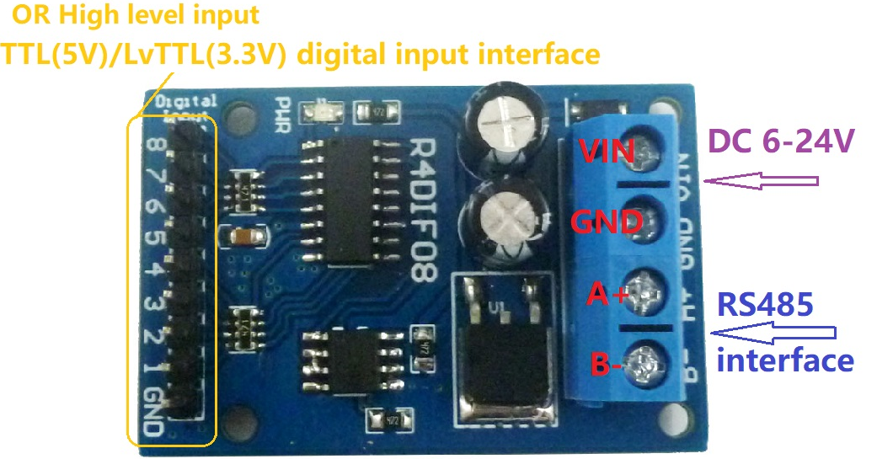

Slave address: different slave addresses can be set by instructions, and the slave address must be correct to communicate.

For instructions, see " R4DIF08 modbus rtu protocol"

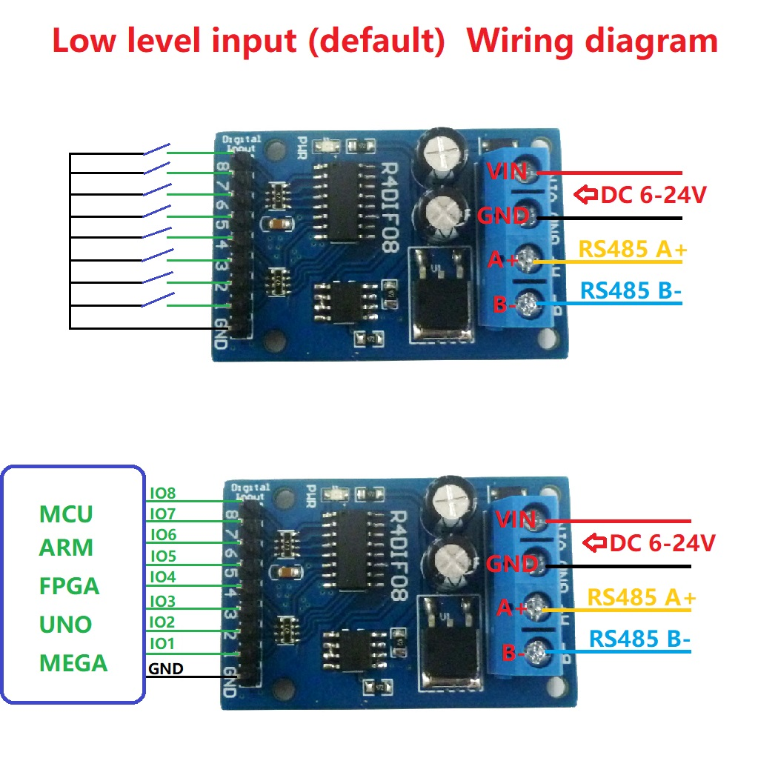

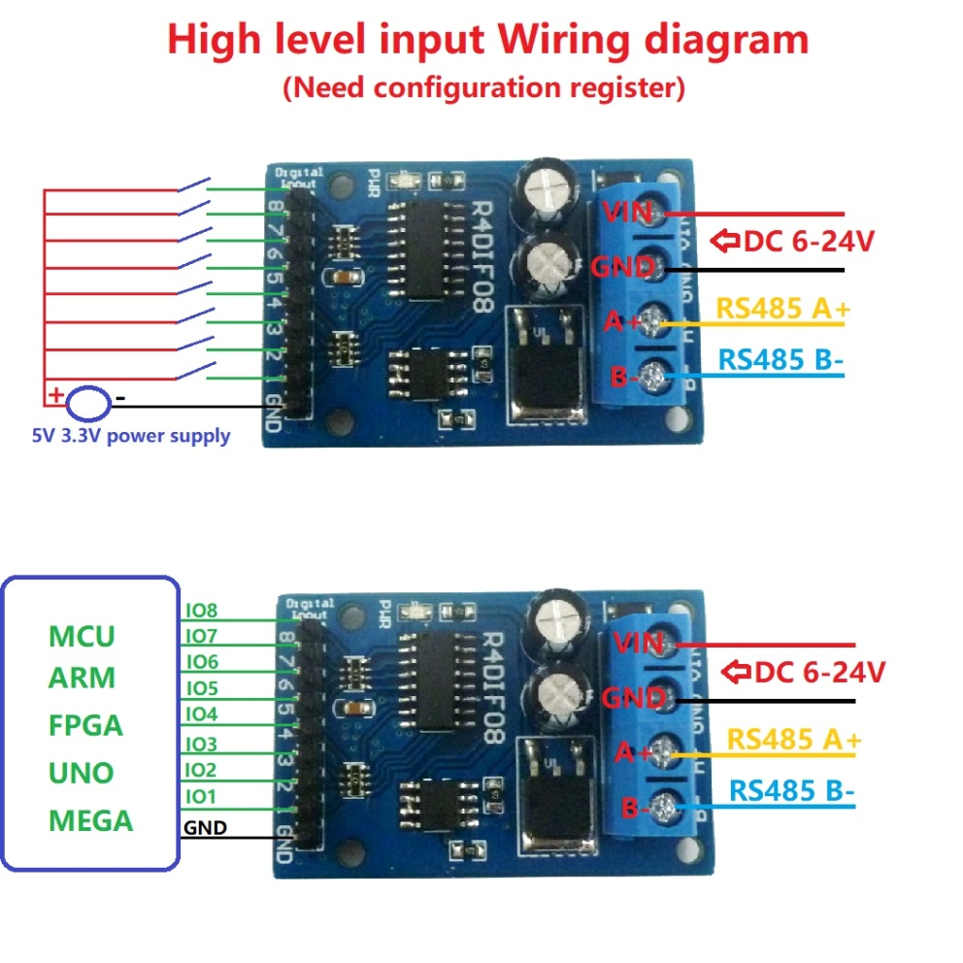

**Wiring diagram:**

